Gopika Menon

CSC 4996

Hashmi

06 September 2017

TODO Application Documentation

**Functional and Non-functional Requirements**

|  |  |
| --- | --- |
| **Functional Requirements** | **Non-functional Requirements** |
| User should be able to successfully Add Tasks to the TODO application | TODO application should respond in less than 2 seconds |
| User should be able to successfully View Tasks in the TODO application | TODO application should be available to the user |
| User should be able to successfully Delete Tasks from the TODO application | TODO application appearance should be clear and concise |

**System Architecture Diagram**

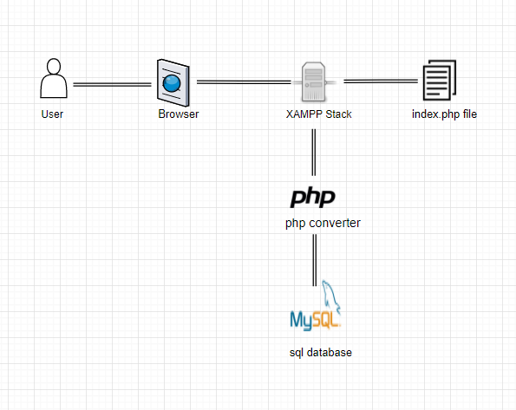

**Data Flow Diagram**

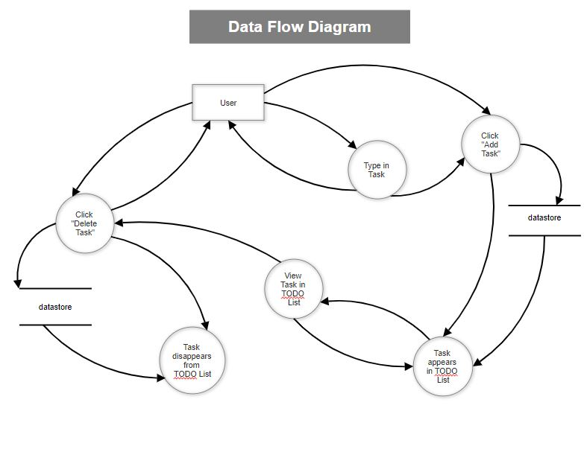

**Use Case**

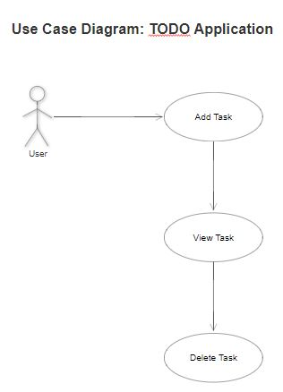

**Add Task Sequence Diagram**

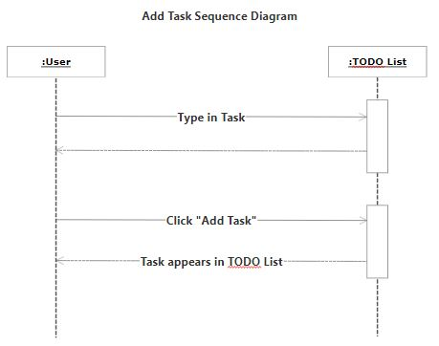

**View Task Sequence Diagram**

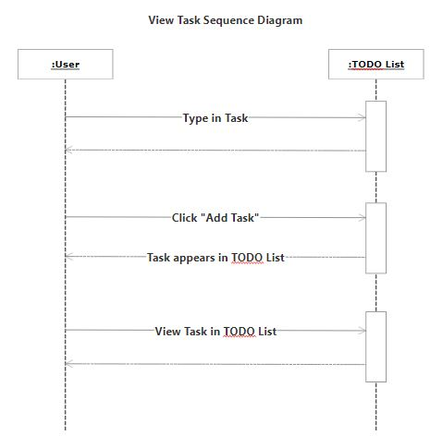

**Delete Task Sequence Diagram**

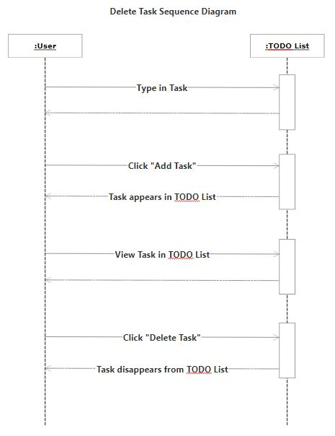

**Database Design**

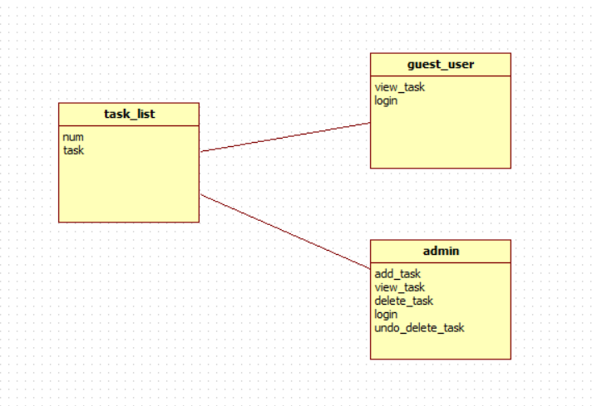

**Class Diagram**

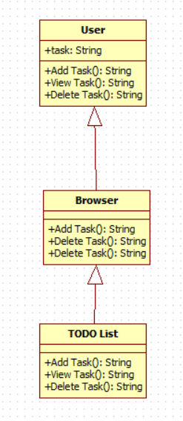

**Test Case**

|  |  |  |
| --- | --- | --- |
| **Case** | **Expected Result (Pass)** | **Actual Outcome (Fail)** |
| User inputs empty task | An error message appears preventing the user from inputting an empty task | The empty task is inputted into the TODO application |
| User inputs duplicate task | An error message appears preventing the user from inputting a duplicate task | The duplicate task is inputted into the TODO application |
| An external user edits the administrator’s TODO application | The application initially requests the administrator’s credential’s before using the TODO application | The external user allows anyone to access and edit the TODO application |

**Work Break Down**

|  |  |  |  |  |
| --- | --- | --- | --- | --- |
| **Name of task** | **Estimated No of Hours** | **Actual Time Spent** | **Notes** | **Issues** |
| Research GitHub | 3 | 2 |  | Misunderstanding regarding adding 4996wsu to the repository |
| Research WAMP/XAMPP/PHP | 3 | 2 | Reviewed CSC 4710 assignments and projects |  |
| Review MySQL | 2 | 1.5 | Reviewed CSC 4710 assignments and projects |  |
| Functional Requirements | 1 | 5 minutes |  |  |
| Nonfunctional Requirements | 1 | 10 minutes |  |  |
| System Architecture Diagram | 1 | 30 minutes |  |  |
| Data Flow Diagram | 1 | 30 minutes |  |  |
| Use Case | 1 | 30 minutes |  |  |
| Sequence Diagram | 1 | 30 minutes |  |  |
| Database Design | 1 | 30 minutes |  |  |
| Class Diagram | 1 | 30 minutes |  |  |
| Test Case | 1 | 20 minutes |  |  |
| Add Task | 1 | 45 minutes |  |  |
| View Task | 1 | 45 minutes | Coincided with “Add Task” function |  |
| Delete Task | 1 | 1 hour |  |  |